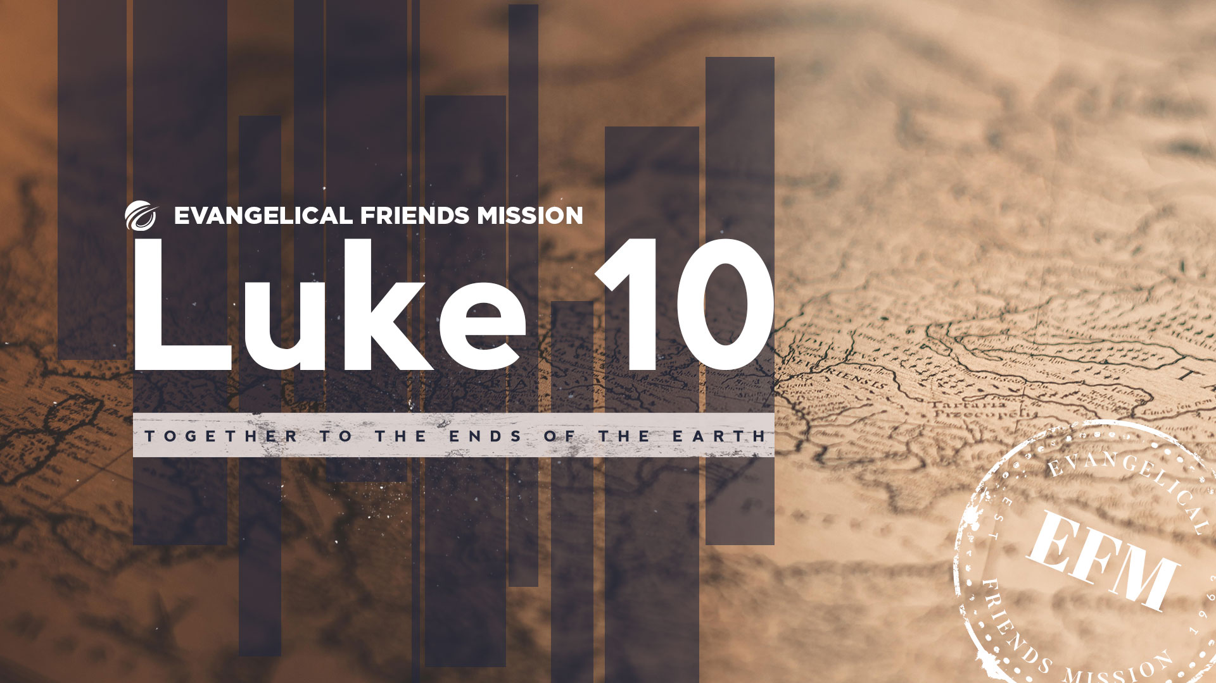

Evangelical Friends Mission
Luke 10 Trips

CAN GO Report

Luke 10 Trip CAN GO Report to EFM

EFM asks that each Luke 10 Exploration Trip team provide a written report summarizing what you are discerning for aligning with EFM’s five criteria for starting a new mission field. EFM calls these criteria “EFM’s CAN GO Criteria.”

Each team’s report will be provided to the EFM Luke 10 Think Tank and EFM Board as we all discern together what the next steps might look like for exploring new fields among the people and place you have visited. (https://friendsmission.com/five-year-goal-go/)
- The following pages serve as notes pages that can be printed off for each team member to make personal notes/observations, so far at this time, on each category before, during, and after the trip.
  - Team members are also welcomed to consider framing strategic observations and planning/ideas around the three phases of Preparation, Participation, and Promotion among Senders, Goers, and Recipients.

- Please use the format below, along with the following seven pages of questions as a guide for the Luke 10 team to present one formal written report to EFM. It should be something like 2 to 6 pages total. The team leader is responsible to see that a report summarizing the consensus of the team is provided to EFM. This report can be downloaded here.

Please start your team written report to EFM with a basic introduction including:
  - Dates of trip and Luke 10 Trip main destination
  - Name of main author/s of report and date submitted
  - Names of each trip team member and where they are from along with their role in the church and maybe a short sentence about why they wanted to participate
  - Very brief schedule description of main activities on Luke 10 Trip, including list of towns or communities (city/state/country) where you visited for exploration.
  - Pertinent information that helps EFM understand your team’s perspectives on:

    - C for Champions
    - A for Affirmation
    - N for Need
    - G for Gifting
    - O for Opportunity
    - Is this a CAN GO for EFM at this time?
    - Luke 10 Team recommendation to EFM

EFM asks that the 2022 trip reports be submitted no later than four weeks after the Luke 10 Trip. The EFM office will be extracting some basic information from these reports to work with trip leaders in providing a brief update to the EFM e-mail list about how the trip went. For those teams going in October, the written CAN GO report to EFM needs to be presented to the EFM National Think Tank on November 1 and 2, 2022.

Luke 10 Trip CAN GO Report to EFM

Team Member Name: _________________________________________________

Trip Location: ________________________________________________________

Trip Dates: __________________________________________________________

C for Champions:
These are people who have a passion for a specific people and place. There is a strong
sense that "We must go there!"

- Who is God already using/calling to be a champion for this place? Churches? Individuals? Partners in other continents? Before the trip? During the trip? After the trip?
- Who is praying for this people or place? Will they pray for the team as they endeavor to dream and receive the vision?
- Who is God calling to give their lives to reaching this people group? What are their names?

BEFORE
DURING

AFTER

A for Affirmation:
This comes from the body of Christ at the local, national, and international levels.
- Are there partners or ministries in place that we can learn from prior to us going there? In the greater region?
- How did the discernment impressions of senders and goers change before, during and after the trip? What discoveries or stories stand out in this process?
- Are there people with resolve willing to partner with and send missionaries to this people or place? Who are they?

BEFORE
DURING

AFTER

N for Need:
There is a compelling need for the gospel in this unreached or under-reached people/place.

- What can you share about this people or place?
- Is there a ministry need that we can focus on?
- How would you summarize the most convincing evidence of need for the gospel and reason/s to start a mission there?

BEFORE
DURING

AFTER
G for Gifting:
There are persons available who have the gifts and character to do pioneering work.

- Who is expressing interest or willingness to consider going as a missionary to this place?
- What sort of gifts or skills might be required for this work?
- How many people will it take to begin this pioneering work? What will it take to get started?
- See Ron Stansell’s article entitled “Team Giftedness in Pioneer Work.”

BEFORE
DURING

AFTER
O for Opportunity:
There is openness in this specific unreached or under-reached people, even a sense of invitation.

- Is the soil ready for sowing seeds of the Good News? (Matthew 13:23: The seed that fell on good soil represents those who truly hear and understand God’s word and produce a harvest of thirty, sixty, or even a hundred times as much as had been planted!”)
- Who welcomed you or provided hospitality among believers and non-believers? Did you find a woman/man of peace? Did you receive an invitation to bring the Good News to an area that is not being reached?
- Share any opportunities that God may be presenting to us. How might we start? How will we engage with the people? Business? Development? Discipleship and Evangelism? Partnerships?

BEFORE
DURING

AFTER
Is this a CAN GO for EFM at this time?

- Please summarize how you see this potential new field most aligning with EFM's vision and mission statements. (https://friendsmission.com/vision-and-mission/)
- EFM's Vision: Evangelical Friends of North America fully mobilized to send missionaries who plant groups of churches around the world that are faithful, sustainable, multiplying and mobilized to send missionaries themselves.
- EFM's Mission: Our purpose and passion is to fuel a worldwide movement of people who seek first the kingdom of God, planting churches that live and die to carry out the Great Commission in the spirit of the Great Commandment.

- Which of the five criteria do we see the strongest? Which of the five criteria is yet to become convincing?

- Describe key points or stories in the process and affirmation/confirmation of God’s call to Evangelical Friends to go to this particular people or place.

- What steps have you taken since returning from the trip or need to take in further discernment or exploration of this field? (Including gathering people together to seek the mind of Christ and to discern God’s call upon our churches to send missionaries to start a new field? (https://friendsmission.com/five-year-goal-go/)

Luke 10 Team Recommendation to EFM

What is the general sense of the team, concerning a recommendation to EFM’s Think Tank?
This is to be a brief summary describing potential next steps in exploration and discernment. Explore further? Pause exploration for now? Recommend that a new field be opened?

